Grant Funding Report
presented to
DINING FOR WOMEN
With gratitude from
The Fistula Foundation

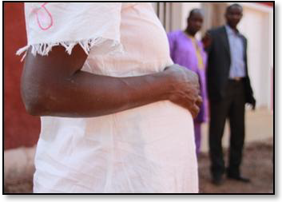
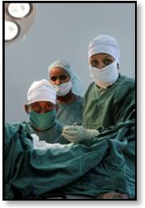
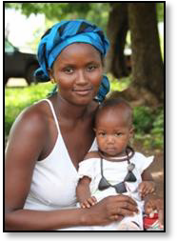

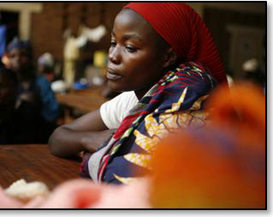

THE FISTULA FOUNDATION
1900 The Alameda, Suite 500, San Jose, CA 95126
Project: OBSTETRIC FISTULA TREATMENT
Grant Amount: $57,106.45
Contact Person: Anne Ferguson

Goals
Obstetric fistula is a heartbreaking injury that devastates the lives of women who suffer from it. Caused by prolonged and unrelieved obstructed labor, an obstetric fistula is a small tear that develops in the birth canal, through which a woman will begin to leak urine, feces or both. The injury is completely preventable when a woman has access to timely obstetric intervention, but in far too many places throughout Africa and Asia, quality care is simply not available; if it is, it is often neither accessible nor affordable.

A woman who has developed an obstetric fistula has typically lost her baby during the prolonged birthing process, and the fistula causes more devastation: uncontrollably leaking bodily wastes she is often rejected by her husband because of her foul smell. She is also often shunned by others as well, and can face profound psychological trauma that results from the loss of her child and the loss of her status in her family and community.

The grant provided to Fistula Foundation from Dining for Women was to be used to treat 66 Ethiopian women suffering from the devastating injury of obstetric fistula at the Hamlin Fistula Hospital, Addis Ababa, Ethiopia.

Findings and Overall Outcomes
The generous 2011 Dining for Women grant of $57,106.45 was used to provide transformative surgeries for women in Ethiopia, a country where fistula is not uncommon. Specifically, your 2011 grant was used to pay for obstetric fistula surgery costs at the Hamlin Fistula Hospital in Addis Ababa, the capital of Ethiopia.

The Hamlin Fistula Hospital since its establishment in 1974 has been the pioneer facility for women suffering from childbirth and related injuries including fistula, rehabilitating them to the point where they can be integrated back into their society with dignity and sense of self-worth and well being. It is located in a region where there is a dramatic need for reproductive health services for women, and where fistula is too common.
The full grant amount of $57,106.45 was disbursed to the Hamlin Fistula Hospital on December 20th, 2011.
Reporting to Fistula Foundation on the use of Dining for Women funds and other funding provided by our organization during Hamlin’s fiscal year of 2011/12, the Hospital registered the following key performance indicators:
- 1,078 patients admitted
- 793 major operations performed**
- 133 minor operations performed
- 1,549 patients treated in physiotherapy.
- 165 patients referred from outreaches treated.
- 17,294 laboratory tests of various types of blood, urine and stool done
- 92 health professionals trained in fistula operations and care.
- 49 high risk mothers cared for safe delivery.
- 1,587 patients attended educational and skills training.

** VVF 401; RVF 30; RVF+VVF 41; Additional surgeries 321.
The stated aim of providing free obstetric fistula surgeries to 66 women via the Dining for Women grant was met, and in fact, exceeded in numerous ways.

Grant Impact
The impact of Dining for Women funds cannot be overstated. For a woman suffering from obstetric fistula, the gift of health is priceless. When her injury is healed, her incontinence ends and she need no longer fear being shunned by her community.

As part of their post-surgical recovery program, Hamlin Fistula Hospital offers the support of psychiatric nurses, a social worker and a Chaplain who work to provide hoslitic care for each woman who comes for treatment.

Surgical treatment is provided free of charge to women with obstetric fistula and related illnesses. The Hospital has the facility and capacity to perform operations on 1,500 patients each year with an approximate 90% success rate (in terms of closing the fistula), enabling most women to return to their husbands or re-marry and perhaps even bear children.

So, as a result of Dining for Women’s generous grant, not only have 66 women regained their health by receiving treatment for their obstetric fistula – these women have received critical post-surgical counseling and reintegration support to help them overcome both the physical and psychological trauma endured due to this injury.

Program Challenges
While the successes at Hamlin Fistula Hospital are profound, Fistula Foundation and our partners believe that it is important to learn from challenges. To this end, these are obstacles the Hospital reported facing in their path to provide women with life-changing surgeries:

- Patient identification and transport to fistula facilities. Even though estimates are of a high prevalence of fistula patients in rural Ethiopia, the numbers of patients arriving at the Hospital’s fistula centers were not as high as anticipated. While this did not impact use of the Dining for Women grant, this situation resulted in an overall lower number of surgeries being performed than planned/targeted annually at the Hospital.
- Surgeon retention. The rigorous surgeon training program at the Hospital has added several surgeons to the field who are now more skilled and capable of performing more complex fistula repairs. However, the Hospital has seen an increase in the number of surgeons leaving Ethiopia for other African countries for better pay. Those that remain in Ethiopia are frequently requesting very high salaries and benefits, which the Hospital cannot afford and, thus, is experiencing some difficulty in retaining experienced surgeons.
- Increased cost of surgery. High inflation and price increases also push up the total and unit costs of operations. In Ethiopia, annual inflation rate is over 40%, which means that funding provided for surgeries sometimes does not stretch as far as the Hospital initially plans that it will.

Program Sustainability

Hamlin Fistula Hospital has been treating fistula patients since 1974. It has grown its fistula treatment program from one facility to seven, and currently provides fistula services at six mini-hospitals strategically located outside of Addis Ababa, in order to serve more women traveling from rural or isolated areas.

Hamlin Fistula Hospital’s continuing objectives are:
- To treat (operate) backlog and new fistula patients to full capacity of their facilities.
- To reach people living in the project areas with preventive and promotion messages.
- To build the capacity of service providers in identification and care of fistula patients.
- To locate and refer fistula patients for repair to the treatment centers.

They will continue to receive funding from partner organizations in support of these objectives.

The 66 women treated as a result of the Dining for Women grant have had their lives transformed. The Hospital does not track the activities of patients after they complete their care, but demonstratively, the beneficial effects of surgery last for the rest of a woman’s life. Healed, she no longer is viewed as an outcast. She can focus on herself, on her family, her education, on a job, and on her community if she chooses, without suffering the burden of incontinence and related stigma.

New Opportunities
Fistula Foundation is honored to have received this generous support from Dining for Women, and are delighted to be associated with this terrific organization, but this grant did not aid us in obtaining further funding or public recognition.

Organizational Information: Fistula Foundation

The Fistula Foundation is dedicated to raising awareness of and funding for fistula treatment, prevention and educational programs worldwide.

Since radically changing our mission in 2009 to fight fistula globally, we’ve expanded rapidly, increasing our total funds raised by nearly 100% even during the “Great Recession” and quadrupling the number of surgeries we are funding. We’ve emerged in the last four years as the largest NGO focused on fistula, supporting 38 projects in 19 countries.
We have a compelling value proposition for our supporters: funds donated to the Foundation change lives because we very effectively and efficiently target funds to treat women at proven facilities in Africa and Southeast Asia. Where many aid organizations spend a majority of their funds on their US-based operation, we turn that around, striving to empower and fund those doing the work on the ground. 80% of our funds go to the programs we fund, and we are committed to continuing to expand the number of women receiving life-transforming treatment.

As Fistula Foundation continues to expand our presence into more facilities, our mission remains clear: to provide life-transforming treatment to as many women with fistula as possible. This sole focus is what makes us so effective at what we do.

Budget

ADDIS ABABA FISTULA HOSPITAL
INCOME AND EXPENDITURE
CO-FUNDING CONTRUBITIONS FOR 2011/2012
INCOME
Donors/partners BIRR % USD
Fistula Foundation USA 7,534,605 20 437,921
AusAID 7,371,461 19
Hamlin Fistula International 8,554,807 22
Ethipiaid UK 6,606,505 17
Ethiopiaid Ireland 1,907,000 5
Hamlin Fistula Sweden 1,473,128 4
Hamlin Fistula Australia
(HFR&AT) 1,150,108 3
Dashen & CBE Banks 1,200,000 3
Fistula Japan 218,022
Others 2,912,904 7
Total Income 38,928,540 100
EXPENDITURE
Salaries and Benefits 18,687,363
Supplies including medicines
& medications 8,258,767
Medical treatment 516,765
Foods 1,762,129
Utilities 598,485
Communications 200,741
Printing & stationeries 316,597
Upkeep & maintenance 857,052
Insurance including Group 2,840,530
International & local
Travels and per diem, staff
Transport 2,209,135
Motors running costs 1,114,803
Generator fuel 222,499
Consultancy fees 419,616
Training & Prof. Dev. 150,341
Others 431,696
Total Expenditures 38,586,519

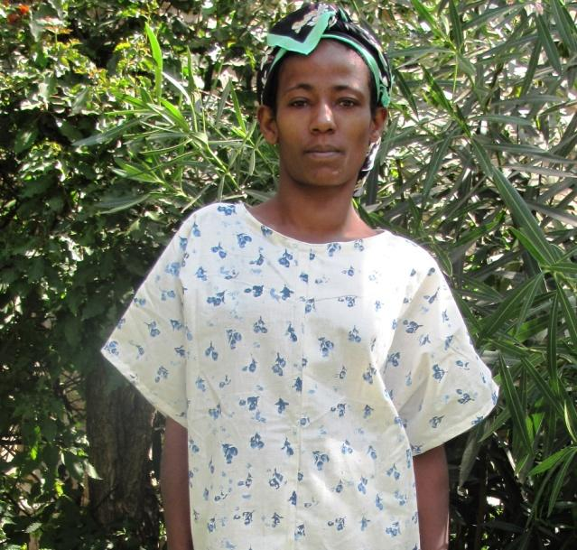
Patient Stories
Lubaba Abebe
Lubaba Abebe, 25, was treated by Hamlin Fistula Hospital. She is from Jimma, Lemu Genet in Ethiopia. Today, Lubaba is very happy to share her experience with others as her surgery at Hamlin Fistula Ethiopia was successful. After her successful treatment she was eager to meet with her husband; when he brought her to the Hospital he was desperate, hoping that a cure could be found for her problem.
She had spent four days in labor which resulted in stillbirth, fistula, and septicemia and bleeding.
Lubaba regained her health through medical treatment, but her obstetric fistula required referral to Hamlin Fistula Hospital. As soon as her husband had the funds for transportation, he took her there and she received all the necessary checkups and fistula surgery.

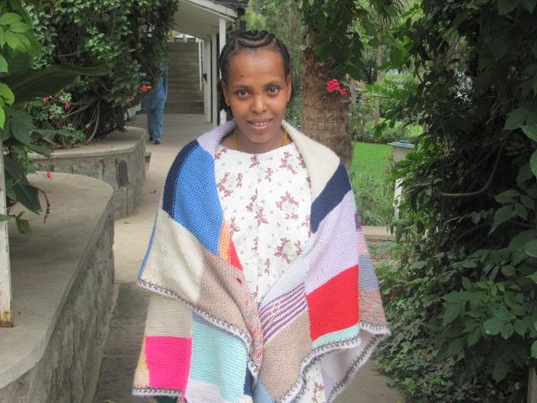
Ambisie Nure
Delay in seeking treatment for obstetric fistula is common, as the normal life for most of patients at Hamlin Fistula Hospital is one of poverty and rural isolation.
Ambisie Nure, 23, developed a fistula five years ago. Even if she had learned about the hospital that treats fistula free of charge while lying hopelessly in small hut, her family did not have the money to pay the transportation cost to the Hamlin Fistula Hospital.
She lives in Bonga, and endured four days of extended labor before her father eventually took her to the local health center. There, she had a still birth and developed a fistula that left her incontinent of urine.
Fortunately, Ambisie was eventually able to contact local missionaries who facilitated her transport to the Hamlin Fistula Hospital. She stated twenty six days at Hamlin Fistula Hospital, and at the end of her stay, she was dry and able to smile again.

Message to Membership and Donors
Fistula Foundation is deeply grateful for the compassion and generosity of Dining for Women members across the country. Your gift helped 66 women receive treatment for their obstetric fistulae that will forever impact their lives. These women now have the priceless gift of health and a second chance at life, all because you chose to “dine in” on their behalf. No woman should suffer a life of misery and isolation, simply for trying to bring a child into this world. From the bottom of our hearts, we thank you for helping to heal women with obstetric fistula.

