Customs and Cuisine of Bali, Indonesia

Bali’s landscape is characterized by abundance: thousands of lush rice fields, coconut palms, tropical fruit trees and coffee plantations; the seas surrounding Bali are rich in fish; and the soil is made fertile by occasional volcanic eruptions of ash and debris.

A significant aspect of dining rituals in Bali consists of offerings made to appease the gods and deities that the Balinese worship on a daily basis. They have remained staunchly devoted to the Hindu religion. Therefore, meals are either “regular daily food,” based on rice with a range of spicy side dishes, vegetables and small amounts of meat or fish, or “festival food,” intended for the gods. Although their spiritual beliefs prevent them from eating beef they do consume pork—it is a very popular festival food—as well as chicken, duck, and fish.

Daily meals are eaten twice a day, with the preparation for both typically done in the morning and left in the kitchen for the family to help themselves to whenever they’re hungry. These meals are not sociable affairs, often eaten quickly and alone. Snacking at street carts and markets is encouraged to stave off hunger until regular mealtime.

In contrast, food for festive occasions is labor-intensive, exquisitely decorated and eaten communally. The people of the village will gather together to help prepare, slice and chop ingredients for their own feast, as well as to elaborately decorate platters of food for the gods. Once the offerings have been made, and the “essence” has been consumed by the gods, the edible portions are enjoyed by the families who brought them.

Rice is the staple food of the Balinese, and the word for cooked rice (nasi) is synonymous with the word for meal. A big plate of steamed white rice is the usual way it is presented, and often at room temperature.
Dewi Sri, the Rice Goddess, is undoubtedly the most worshipped deity in Bali. Her likeness is represented all over the island; as an hourglass figure often made from rice stalks, engraved or painted onto wood, or even made out of cooked rice!

Although bland white rice is a staple food, the Balinese do their very best to jazz things up. Besides white rice, coconut works its way into almost every dish. Food is flavored from a vast array of the many spices, wild herbs and fragrant roots that grow on the island. These ingredients are turned into spice pastes, called bumbu-bumbu, that are typically pounded in a mortar and can take up to 30 minutes to pulverize! Thankfully we have food processors that can reduce this task to minutes.

Dining Etiquette
Eating with your right hand is traditional, although spoons and forks are popular with the younger generation. The fork is held in the left hand to move food onto the spoon.

Hands must be washed before and after eating. The left hand is never used to eat or pass food.

Do not begin to eat or drink until the oldest man at the table has been served and has begun.

The most honored position is in the middle of the table, with the second most important person seated next.

Source material: The Food of Bali, Periplus Edition

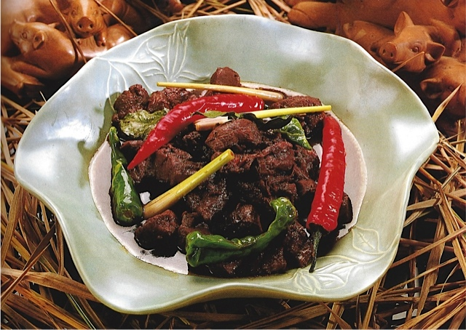
Pork in Sweet Soy Sauce
(Be Celeng Base Manis)

This pork dish often appears on festive occasions, when a whole pig is slaughtered. It includes one of my very favorite condiments, “kecap manis,” or sweet soy sauce. You should find it readily at an Asian market, but in case you don’t want to buy a whole bottle of the stuff I’ll tell you how to make an acceptable substitute. But I promise that if you do buy a whole bottle you will find many ways to drizzle it on everything!

Ingredients
2 tablespoons oil
5 shallots, peeled and sliced
5 cloves garlic, peeled and sliced
1 ¼ pounds boneless pork shoulder or leg, cut into ¾” cubes
3” piece of ginger root, peeled and sliced lengthwise, cut into matchsticks
4 tablespoons kecap manis (sweet soy sauce – or substitute, recipe below)
2 tablespoons thin soy sauce
1 teaspoon black peppercorns, crushed
2 cups chicken stock
6-10 bird’s-eye chilies, left whole

Directions
Heat the oil in a wok or a heavy saucepan. Add shallots and garlic and sauté for 2 minutes over medium heat or until lightly colored. Add pork and ginger and continue to sauté for 2 more minutes over high heat. Add both types of soy sauce and black pepper and continue sautéing for 1 minute.

Pour in chicken stock, add chilies and simmer over low heat for approximately 1 hour. When done, there should be very little sauce left and the meat should be tender, shiny and dark brown. If the meat becomes too dry during cooking add a little chicken stock or water.

Substitute for kecap manis: Mix together 1 part molasses, 2 parts brown sugar, 3 parts soy sauce. Add crushed garlic and ground star anise, or star anise pod. Heat the mixture until the sugar dissolves.

Recipe source: The Food of Bali, Periplus Edition

Indonesian Spice Cake (Spekkuk Bumbu)
Makes one 8” or 9” cake

This is a butter-rich spice cake, and would be made for an important guest or special occasion due to the high amount of butter and eggs. It can be made in one-layer, or a bundt pan, but if you’d really like to get fancy it can be made in several layers as well. It will not taste any different, or better, but it promises a more dramatic look. This recipe gives instructions for the basic one-layer version, but I’ve included the link for the layered version in case you’d like to try that one instead.

Ingredients
1½ cups butter, softened
2 cups cake flour (not self-rising), sifted
1 tablespoon ground cinnamon
1 teaspoon freshly grated nutmeg
½ teaspoon baking powder
½ teaspoon ground cloves
Pinch of salt
1 2⁄3 cups sugar
4 large eggs
3 large egg yolks*, lightly beaten
2 teaspoons vanilla extract

Directions
Preheat oven to 325°. Grease and flour either an 8" × 8" × 2" cake pan or a 9” tube pan - if your pan is non-stick no need to grease and flour.

Sift flour, cinnamon, nutmeg, baking powder, cloves, and salt together into a medium bowl.

Beat 1½ cups butter in a large bowl, using a stand mixer on high speed, (or a wooden spoon), until it is soft and very pliant, about 4 minutes. Add sugar and beat together until pale and fluffy, 5–6 minutes. Beat in whole eggs, one at a time, until mixture is light and fluffy, about 4 minutes.

Reduce mixer speed to low and add flour mixture in 3 equal parts, to make a smooth batter. Add egg yolks and vanilla and continue to mix until well combined, about 30 seconds more.

Pour batter into prepared pan, spread evenly and bake until golden brown and a toothpick inserted in the middle of the cake comes out clean, about 1 hour, but I’d recommend checking it after 45 minutes.

Remove the pan from the oven and let the cake cool in the pan on a wire rack for 10 minutes. If necessary, carefully run a thin knife around the perimeter and inner rim of the cake to help loosen it from the pan. Invert the pan onto the rack and lift it off. Turn the cake right side up and let it cool on the rack.

Transfer the cake to a serving platter. Using a fine-mesh sieve dust the top with powdered sugar, if desired.

Notes: Make sure to freeze your extra egg whites in ice cube trays and pop into zip-lock bags for use in future recipes.

Recipe source: Cradle of Flavor, by James Oseland
Indonesian Spice Cake – Layered Version

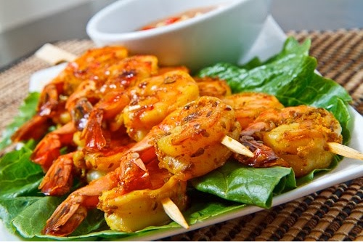

Shrimp Sate (Sate Udang) (Tested)
Yield about 25 to 30 shrimp

Sate (Indonesian spelling) or Satay (Malaysian spelling) is one of the most loved foods in Southeast Asia. Indonesia is THE home of Sate, believed to have originated from the island of Java, but it is also popular in many Southeast Asian countries now.

Sate is a very common street food in Indonesia. There are no less than 29 types of Sate available, and they are usually named after the town of origin or method of cooking. The seafood sate sold in Bali has beautiful distinct flavors. Instead of being doused in rich sweet peanut sauce, it is served plain, fresh off the grill without any sauce–letting the sweet flavors of char-grilled seafood and exotic spices burst in the mouth.

Ingredients
1 1/2 pounds large shrimp (16-20 size), peeled and deveined
1 lime
1 cup spice paste
Bamboo skewers

Directions for Shrimp
Squeeze the juice of one lime on the shrimp and let marinate for 15 minutes. Add the spice paste, mix well, and marinate for 1 to 3 hours. Thread the shrimp onto skewers and grill or broil. You want the heat to be high so that the shrimp cook quickly and get a little char on them. If your grill is hot enough it should take about 2-3 minutes per side.

Seafood Spice Paste
Makes one cup

Ingredients
5 large red chilies (Holland or Korean), chopped
7 shallots, peeled and chopped
3 cloves garlic, peeled and chopped
2” piece of ginger, peeled and chopped
2” piece of fresh turmeric, peeled and chopped (or 2 teaspoon powdered – see Note 1 below)
1 small tomato, peeled and chopped
1 1/2 teaspoons coriander seeds, crushed
5 candlenuts (10 macadamia nuts can be substituted – see Note 2 below)
1 teaspoon dried shrimp paste (see Note 3 below)
1/2 teaspoon salt
1/4 cup coconut milk
2 tablespoons oil
2 tablespoons tamarind pulp (see Note 4 below)
1 stalk lemongrass, outer leaves removed, tied in a knot

Directions for Seafood Spice Paste
Process all ingredients except for oil, tamarind, lemongrass and coconut milk until they turn into a coarse paste. Can be made one week ahead and refrigerated.

Heat the oil in a sauté pan and add the spice paste, tamarind pulp and lemongrass stalk. Saute for about five minutes, stirring occasionally, until mixture smells fragrant, not harsh and raw anymore. Stir in coconut milk and let cool.

Recipe source: The Food of Bali

Recipe Notes:

1 - Turmeric will stain your fingers yellow if you handle it and chop it, you may want to wear gloves.

2 - Candlenuts are used to add body and thickness, and are not to be eaten raw, in fact if you eat any they can be mildly toxic. Once they are ground up and cooked they are harmless.

3 - Indonesian shrimp paste comes in a block and is brown and quite pungent. Since the recipe only calls for 1 teaspoon feel free to omit if you don’t want to make this purchase.

4 - I used tamarind concentrate from a jar rather than soaking the pulp in water and straining it.

Tip - Make sure to freeze leftover coconut milk in ice cube trays and pop into a zip-lock bag for future use.

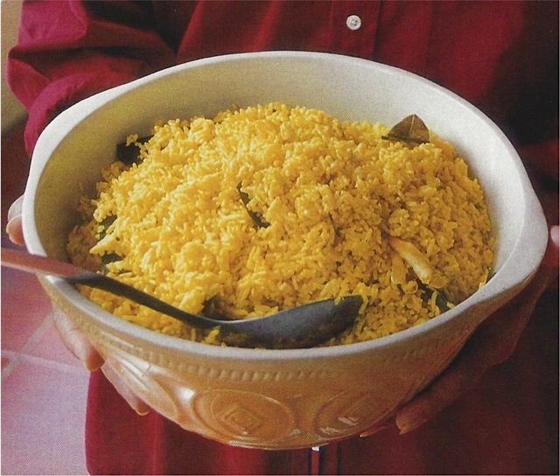

Festive Yellow Rice (Nasi Kuning)
Serves 6-8

For every day meals plain, steamed white rice would be served. Yellow, one of the four sacred colors, makes this festive rice dish strikingly different from the daily fare.

Ingredients
3 fresh or frozen whole daun pandan (pandanus or screw pine leaves – see note below)
2 thick stalks fresh lemongrass, trimmed
2 cups jasmine rice
1½ teaspoons ground turmeric (not fresh)
1 cup unsweetened coconut milk
3 whole fresh or frozen kaffir lime leaves, crumbled
Salt

Directions
Tie each daun pandan leaf in 3–4 knots; set aside (if you can’t find pandan just skip it). Remove and discard outer leaves of lemongrass and, using a blunt object such as the smooth side of a meat mallet, bruise stalks until they are slightly shredded and flexible, then tie each in a knot; set aside.

Put rice into a 2-quart pot, cover with cold water, and gently swish around with your hand until water clouds; drain water. Repeat process 3 more times (water will run clearer but will still be slightly cloudy). Put turmeric and 1½ cups water into a small bowl; stir to combine. Add turmeric water, daun pandan, lemongrass, coconut milk, kaffir lime leaves, and salt to taste to rice pot; stir well. Bring rice mixture to a rolling, noisy boil over high heat, stirring constantly, to prevent rice from sticking to bottom of pot. Allow to boil for 15 seconds, stirring constantly, then reduce heat to low, cover, and cook for 15 minutes more (don't lift lid). Remove from heat and keep covered for 10 minutes more.

Remove lid and transfer rice to a serving bowl; fluff it gently with a fork.

Recipe source: Saveur.com

Note: The leaves of the pandan plant are long and sword-like; they give a vanilla-like taste and fragrance to curries and rice dishes. They are available fresh and frozen and are usually found next to the frozen banana leaves in Asian markets. They will usually be labeled “bai toey,” as they are known in Thailand, the country from which they are most often imported.

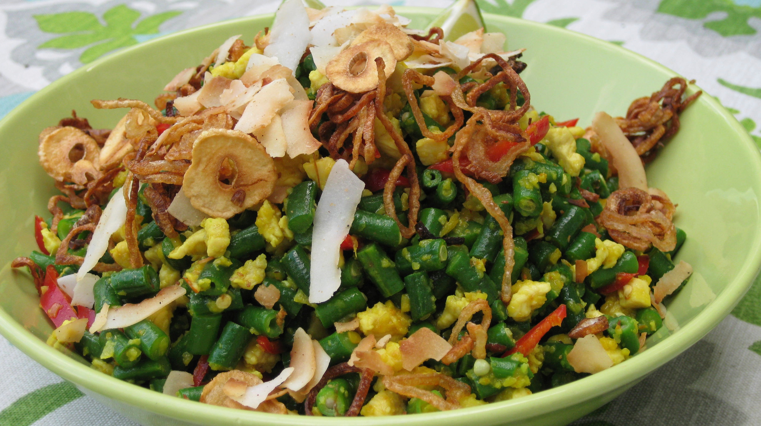

Chicken and Green Bean Salad (Lawar) (Tested)

Lawar (finely chopped meat and spices) is one of Bali’s most famous dishes. An entire day beforehand may be spent preparing the many ingredients that go into an elaborate Lawar that will feed an entire village.

Most of the ingredients in the spice paste can be found in a well-stocked Asian grocery. Any that can’t, can be eliminated and the dish will still be delicious.

The spice paste can be made a week ahead of time. The green beans and chicken can be prepped a day ahead of time and stored separately in the fridge. Then all that’s left is to fry your shallots and garlic and toss everything together.

Serves 8-10
Spice level – Three Stars

- Ingredients
- 3 cups blanched Chinese long beans or regular green beans (about 1 1/2#)
- 2 large fresh red chilies, (Holland or Korean) cut in fine strips
- 4-6 bird’s eye chilies (can substitute serrano chilies, to taste), finely sliced
- 4 tablespoons spice paste, see below
- 1/2 pound boneless chicken breast, minced
- Juice of 1 lime
- 1 teaspoon kosher salt
- 1/2 teaspoon black peppercorns, crushed

Garnishes
- 1/2 cup toasted coconut chips
- 6 cloves garlic – peeled, sliced & fried
- 6-8 shallots – peeled, sliced & fried
Lime wedges

Directions
To blanch the beans, drop them into rapidly boiling water; as soon as the water comes back to a simmer, drain and shock them in an ice-water bath to stop the cooking immediately. Drain well and dry on a tea towel, then cut into small dice. Combine beans, chilies, 2 tablespoons of the spice paste and a healthy sprinkle of salt in a large bowl and mix well.

Next, combine the chicken mince with 2 tablespoon of the spice paste and stir-fry in a bit of oil until cooked through. Salt to taste and let cool. Combine chicken with the bean mixture, season to taste with salt, pepper, and lime. Stir in half the
coconut, garlic and shallots. Mound in a serving bowl, and garnish with the remaining coconut, garlic and shallots. Serve with limes for squeezing on top.

To fry shallots: Slice as thinly as possible. I have a very inexpensive plastic mandolin that did the trick very well.
Pour about ½ cup oil into a medium sized sauté pan and add shallots when oil is hot. As the shallots begin to brown keep stirring and turning heat down so they don’t burn. This process takes about 10 minutes. Once they are just a bit darker than medium-brown remove from the oil to a paper towel and drain. They will continue to darken and crisp as they cool. Can be made one day ahead and stored in a glass jar.

To fry garlic: Same procedure as shallots, but it will take less time. Just fry until the garlic takes on some golden color; you don’t want your garlic to be brown as it will be bitter. Can be made one day ahead of time and stored in a glass jar.

To toast coconut: Heat up a heavy bottom sauté pan and add the coconut. Over medium-high heat, stir the coconut until tinged with brown edges. You may have to turn down your heat as it becomes toasted so it doesn’t burn. Can be made one day ahead of time and stored in a glass jar.

- Spice Paste for Chicken

Ingredients
- 7 shallots, peeled and chopped
- 12 cloves of garlic, peeled and chopped
- 1/2" kencur (can substitute ginger), peeled & chopped – See Note 1 below
- 1” galangal (or laos), peeled and chopped – See Note 2 below
- 5 candlenuts (can substitute 10 macadamia nuts) – See Note 3 below
- 2" fresh turmeric, peeled and chopped (or 2 teaspoons powder) – See Note 4 below
- 2 tablespoons chopped palm sugar, or brown sugar
- 2 tablespoons vegetable oil
- 1 stalk lemongrass, outer leaves removed, lightly pounded, tied in a knot
- 1 salam leaf – See Note 5 below
- 5 bird’s eye chilies (or serrano chilies to taste), finely sliced

Directions
Put shallots, garlic, kencur, galangal, candlenuts, turmeric and palm sugar into a food processor and grind coarsely. Heat oil and add the paste, as well as the lemongrass stalk, salam leaf, and chilies. Fry all ingredients until mixture becomes fragrant an no longer smells harsh and raw, stirring frequently, until the paste changes to a golden color. Remove lemongrass and salam, cool before using. Can be made one week ahead of time.

Note 1 - Kencur: Sometimes erroneously known as lesser galangal. Substitute ginger if you cannot find this.

Note 2 - Galangal or laos: Member of the ginger family, has a very tough root that must be peeled before use. Substitute ginger if you cannot find this.

Note 3 - Candlenuts: Used to add body and thickness and not to be eaten raw, in fact if you eat any they can be mildly toxic. Once they are ground up and cooked they are harmless. Substitute twice as many macadamia nuts.

Note 4 - Turmeric will stain your fingers yellow if you handle it and chop it, you may want to wear gloves.

Note 5 - Salam leaves: Subtly flavored leaf from the cassis (cinnamon) family. If you cannot find obtain omit altogether.

